**‘AccessBank DBA Internship Program’**

**Project 2: Create new databases,** **Attach Adventureworks2014 Database and Document your Server/Database**

This project consists of the IT Director asking for the following:

* Create a new database called FinanceDB, which will be used for 1C accounting program, with GUI using the following sizing parameters:

**Initial size:** between 20-50 MB

**Auto growth:** 10 MB

**Recovery model:** simple

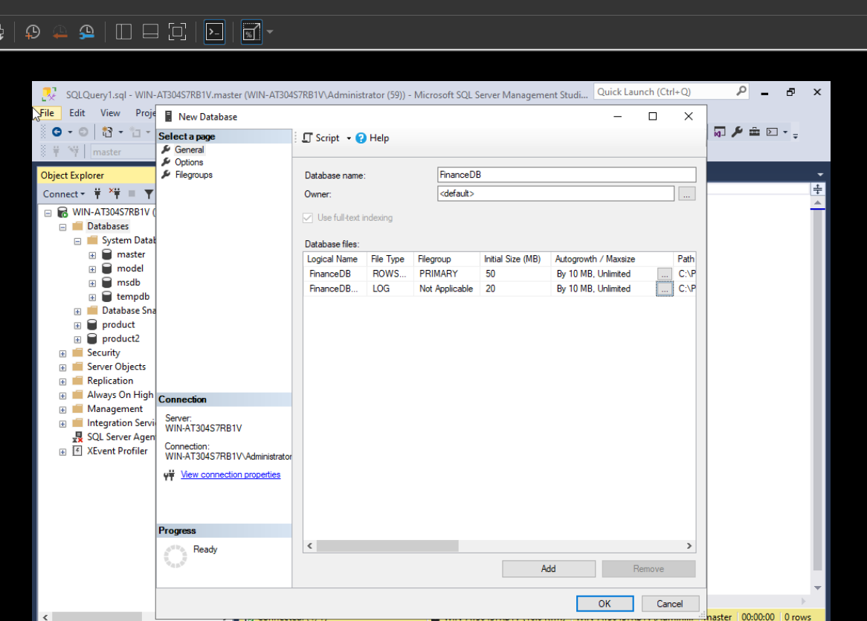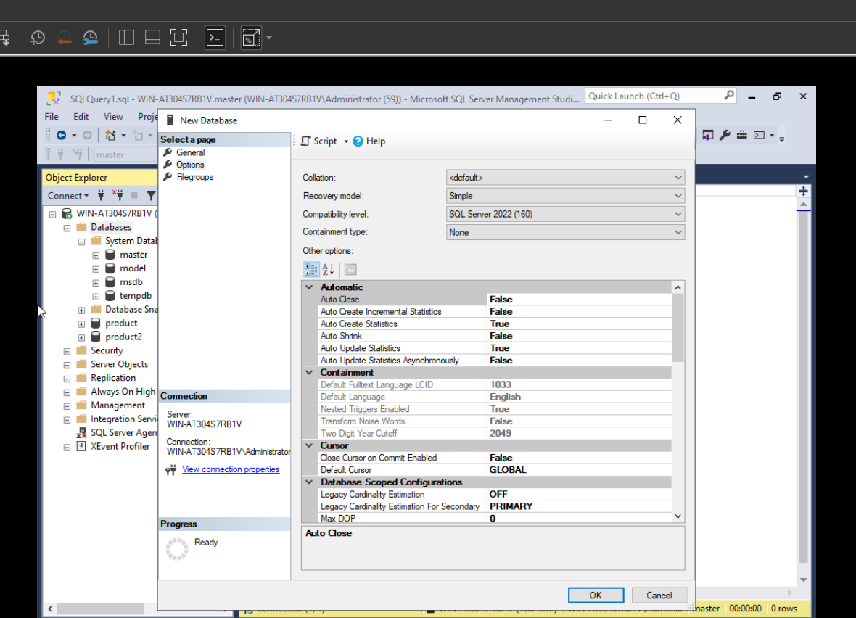

* Create a new database called HRDB, which will be used for Document Management Application, with T-SQL using the following sizing parameters:

**Initial size:** between 50-80 MB

**Auto growth:** 20 %

**Recovery model:** full

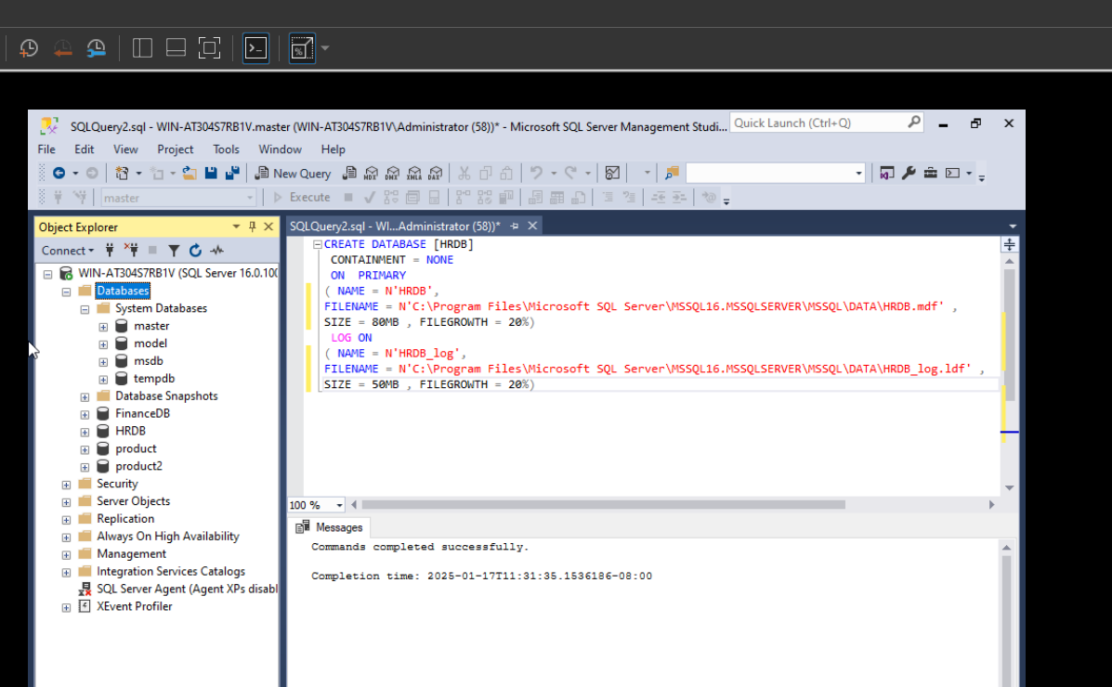

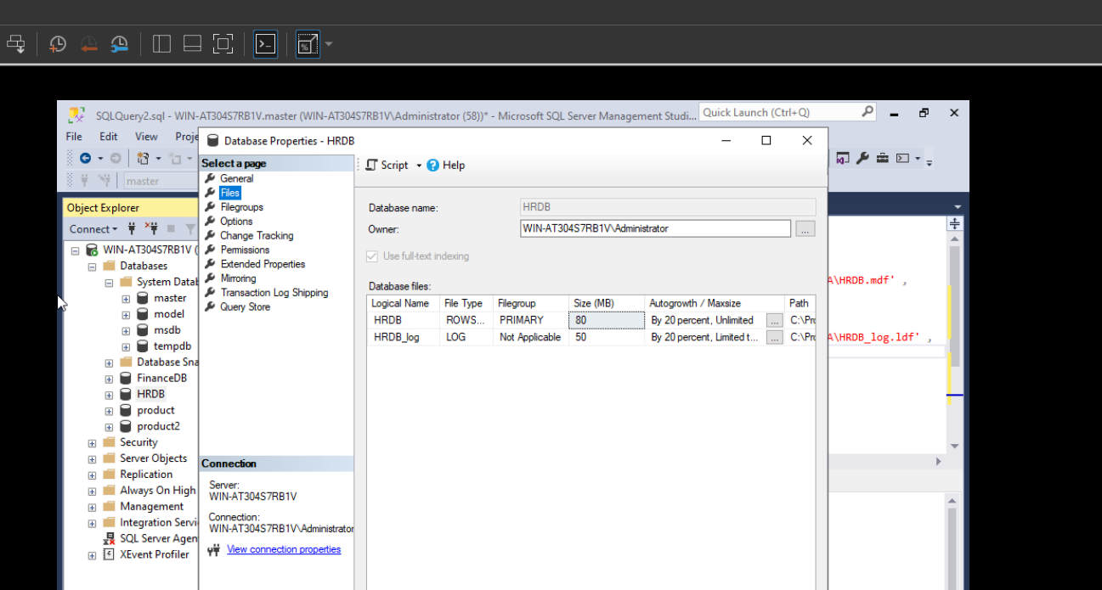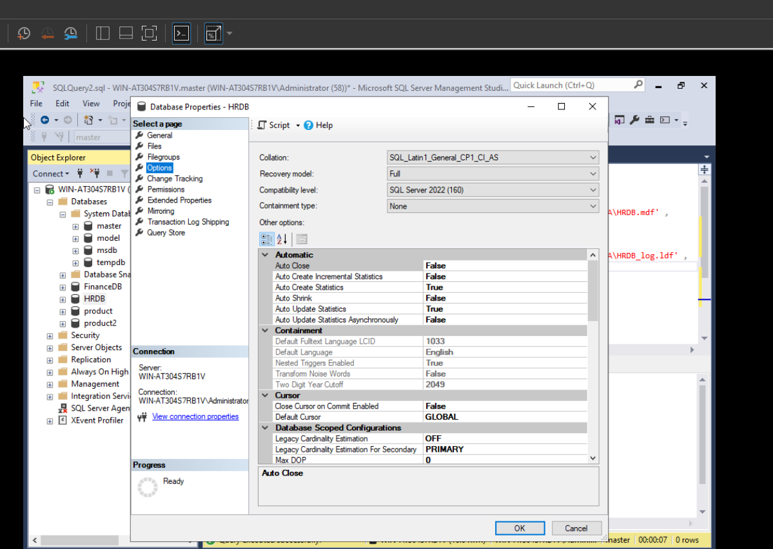

* Attach Adventure works 2014 database

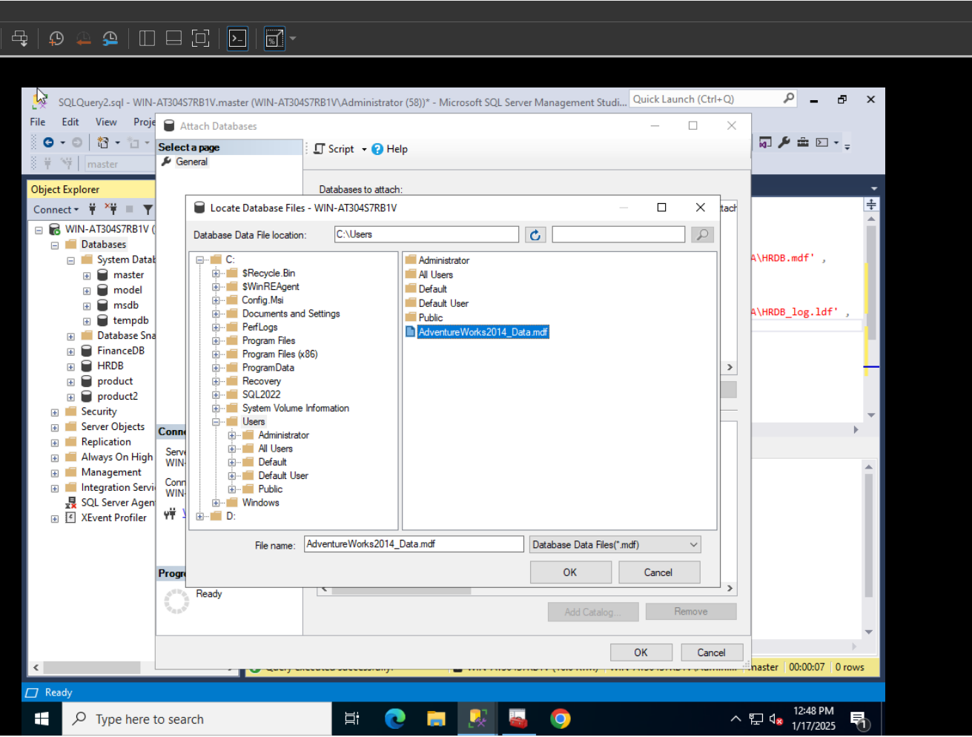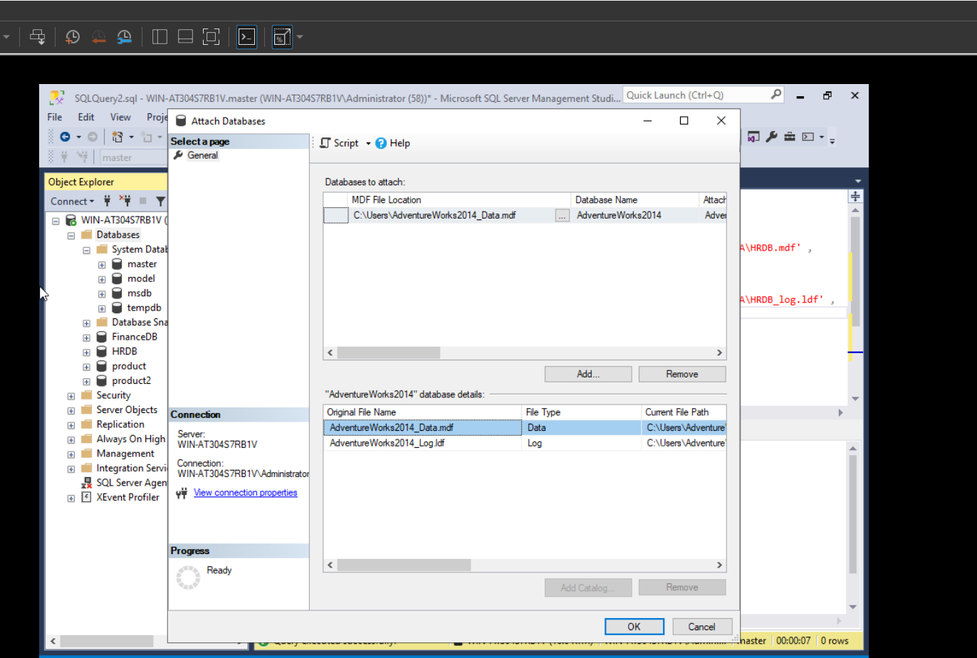

**Turn off auto-update statistics**

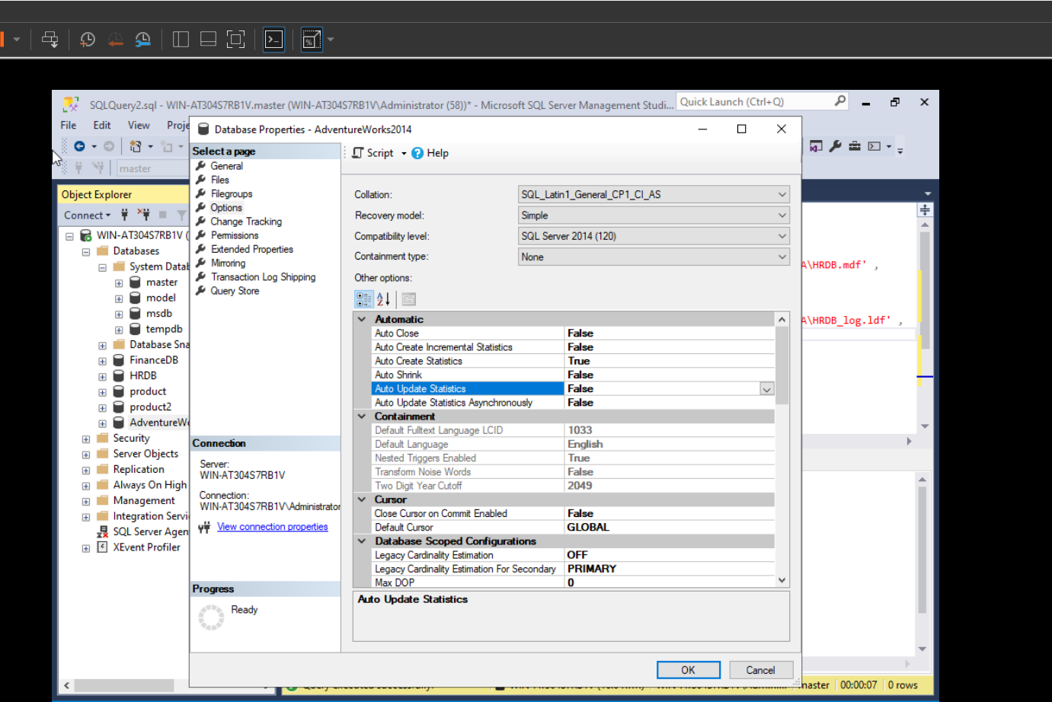

* Test Adventure works 2014 database by:

Writing a SELECT query that will retrieve the Title, FirstName, LastName, and Suffix columns from the Person.Person table

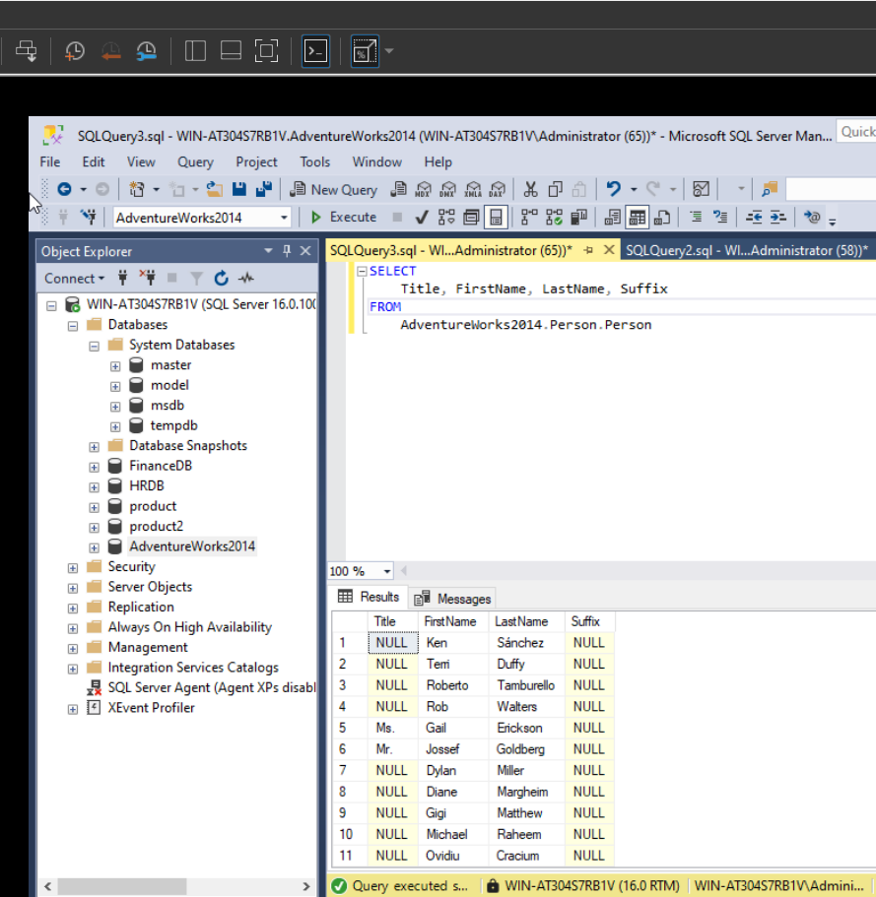

Writing a SELECT query that will list the FirstName and LastName from Person.Person, as well as the BusinessEntityID from Sales.Customer, all in a single result table. Include only those customers who have a PersonID that is not null

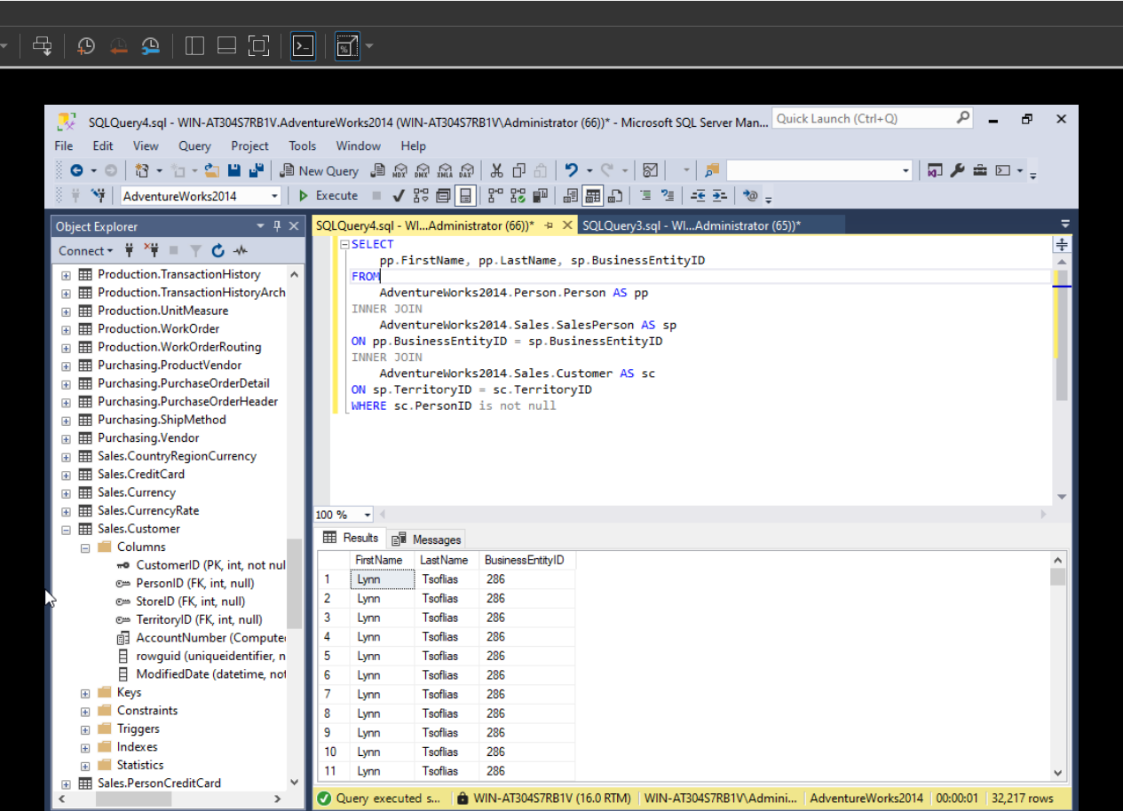

* Document your Server and 2 databases (FinanceDB and HRDB) using the below forms:

**SQL Server Inventory Sheet**

|  |  |
| --- | --- |
| Server name | **WIN-AT304S7RB1V** |
| Instance name | **MSSQLSERVER** |
| SQL Server version | **Microsoft SQL Server Developer (64-bit) 16.0.1000.6** |

|  |  |  |
| --- | --- | --- |
| Database name | Purpose | Data location |
| **FinanceDB** | **will be used for 1C accounting program** | **C:\Program Files\Microsoft SQL Server\MSSQL14.MSSQLSERVER\MSSQL\DATA\FinanceDB.mdf** |
| **HRDB** | **will be used for Document Management Application** | **C:\Program Files\Microsoft SQL Server\MSSQL14.MSSQLSERVER\MSSQL\DATA\HRDB.mdf** |
|  |  |  |
|  |  |  |
|  |  |  |
|  |  |  |
|  |  |  |
|  |  |  |
|  |  |  |
|  |  |  |

|  |  |
| --- | --- |
| Authentication mode | **Windows Authentication mode** |
| Members of **sysadmin** fixed server role | **WIN-AT304S7RB1V\Administrator**  **NT Service\MSSQLSERVER**  **NT Service\SQLSERVERAGENT** |
| Service account | **NT Service\MSSQLSERVER** |
| Agent service account | **NT Service\SQLSERVERAGENT** |
|  |  |

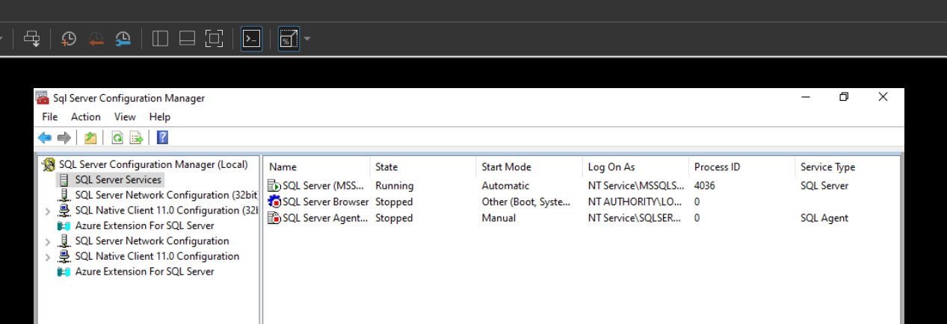

**Database Inventory Sheet**

|  |  |
| --- | --- |
| Server name | **WIN-AT304S7RB1V** |
| Instance name | **MSSQLSERVER** |
| SQL Server version | **Microsoft SQL Server Developer (64-bit) 16.0.1000.6** |

|  |  |  |
| --- | --- | --- |
| Database name | **FinanceDB** | |
| Used by (application name) | **1C accounting program** | |
| Key Options | ☐ Auto-Shrink  ☐ Auto-Close  **☐ Auto-Create Stats**  **☐ Auto-Update Stats**  ☐ Auto-Update Stats Async  Recovery model: **Simple** | |
| MDF File | Location | **C:\Program Files\Microsoft SQL Server\MSSQL14.MSSQLSERVER\MSSQL\DATA\FinanceDB.mdf** |
|  | Size | **50MB**☐ Auto-Grow by **10MB** |
| LDF File | Location | **C:\Program Files\Microsoft SQL Server\MSSQL14.MSSQLSERVER\MSSQL\DATA\FinanceDB_log.ldf** |
|  | Size | **20MB**☐ Auto-Grow by **10MB** |

**Database Inventory Sheet**

|  |  |
| --- | --- |
| Server name | **WIN-AT304S7RB1V** |
| Instance name | **MSSQLSERVER** |
| SQL Server version | **Microsoft SQL Server Developer (64-bit) 16.0.1000.6** |

|  |  |  |
| --- | --- | --- |
| Database name | **HRDB** | |
| Used by (application name) | **Document Management Application** | |
| Key Options | ☐ Auto-Shrink  ☐ Auto-Close  **☐ Auto-Create Stats**  **☐ Auto-Update Stats**  ☐ Auto-Update Stats Async  Recovery model: **Full** | |
| MDF File | Location | **C:\Program Files\Microsoft SQL Server\MSSQL14.MSSQLSERVER\MSSQL\DATA\HRDB.mdf** |
|  | Size | **80MB**☐ Auto-Grow by **20%** |
| LDF File | Location | **C:\Program Files\Microsoft SQL Server\MSSQL14.MSSQLSERVER\MSSQL\DATA\HRDB_log.ldf** |
|  | Size | **50MB**☐ Auto-Grow by **20%** |